Positive cases:

1. Upon giving valid format Asset – It displays in Green and shows Correct format.

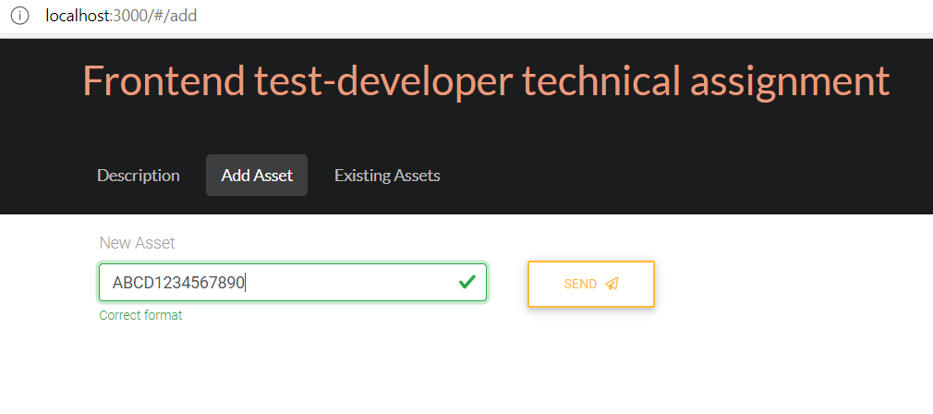

1. On Clicking ‘SEND’ a message prompt with the valid details with ‘CLOSE’ button.

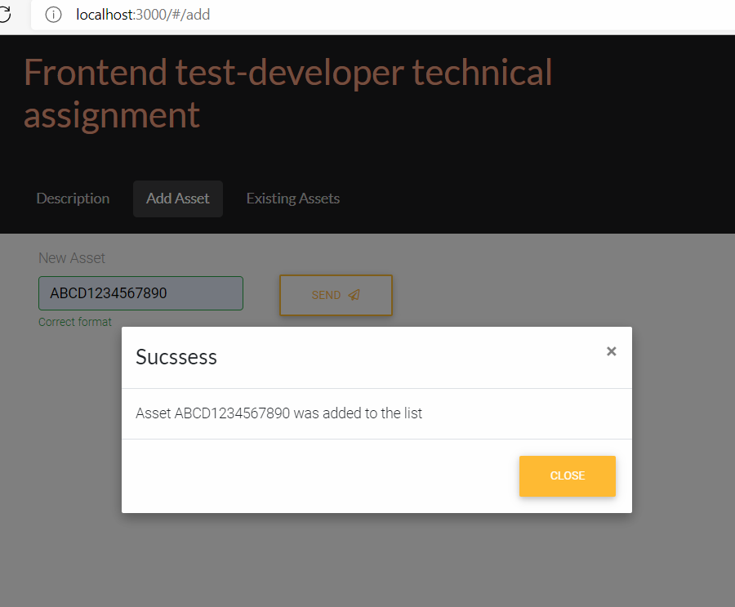

1. Entering the same Asset again and on Clicking on ‘SEND’ prompts a valid message with ‘CLOSE’ button.

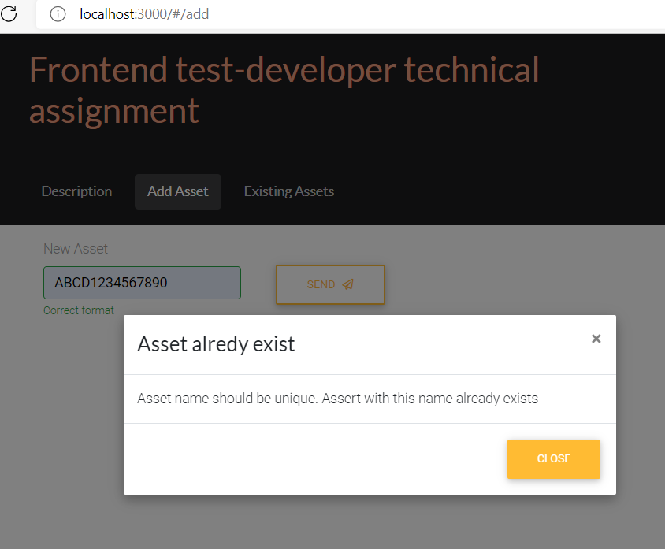

1. All the list of Assets created shows up based on the entry selected.

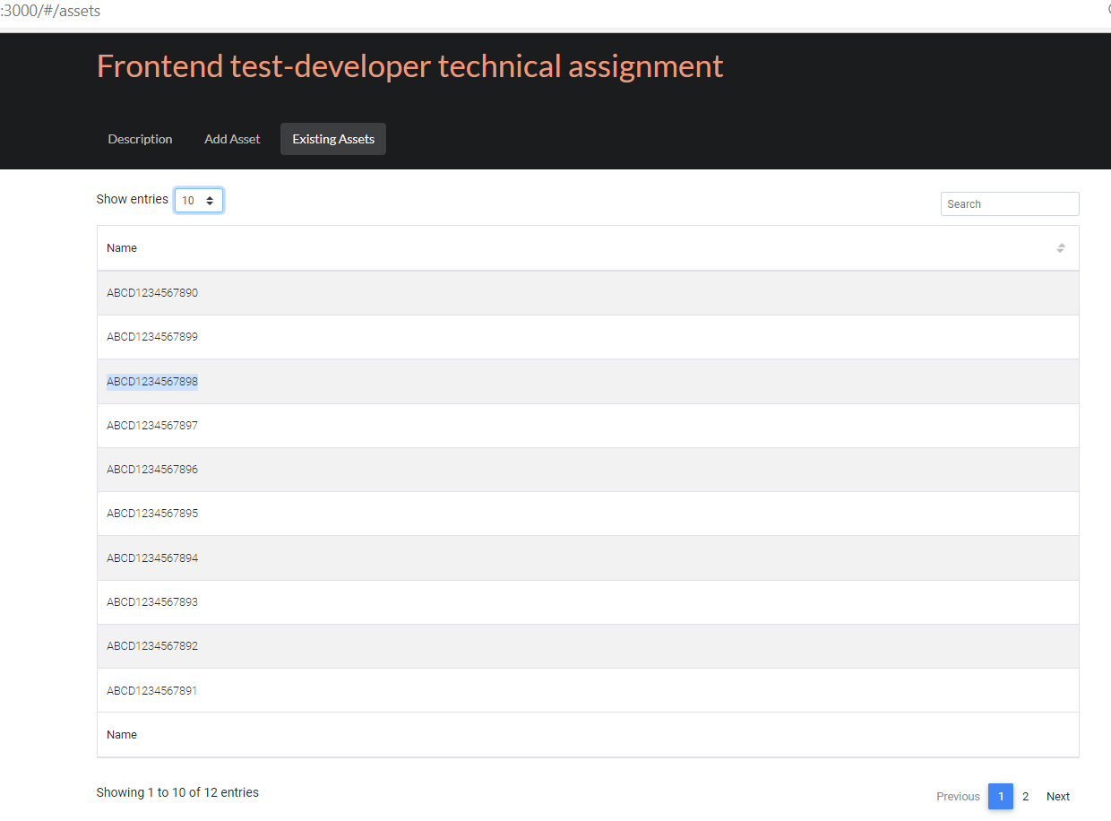

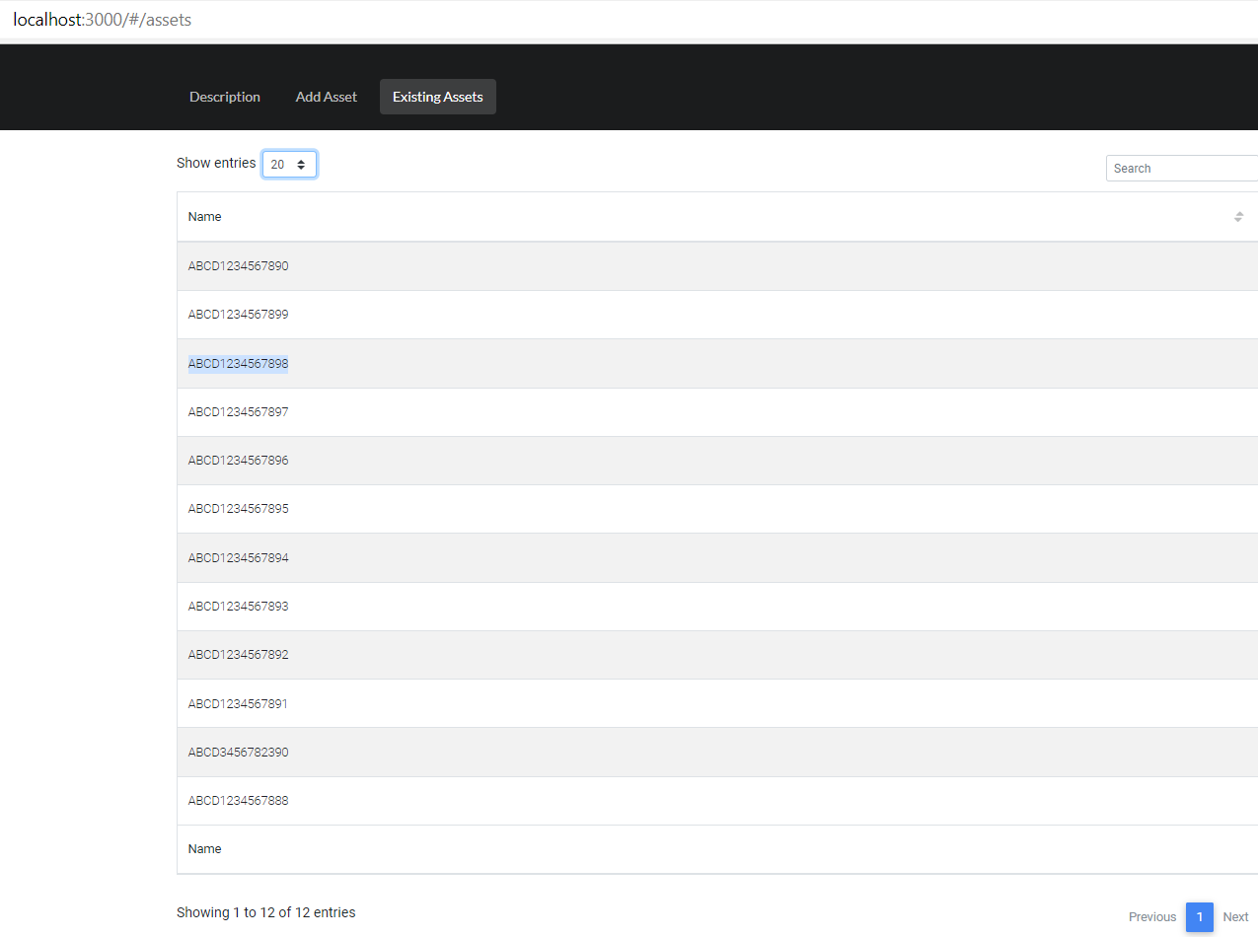

1. Search Criteria – Returns the value searched for

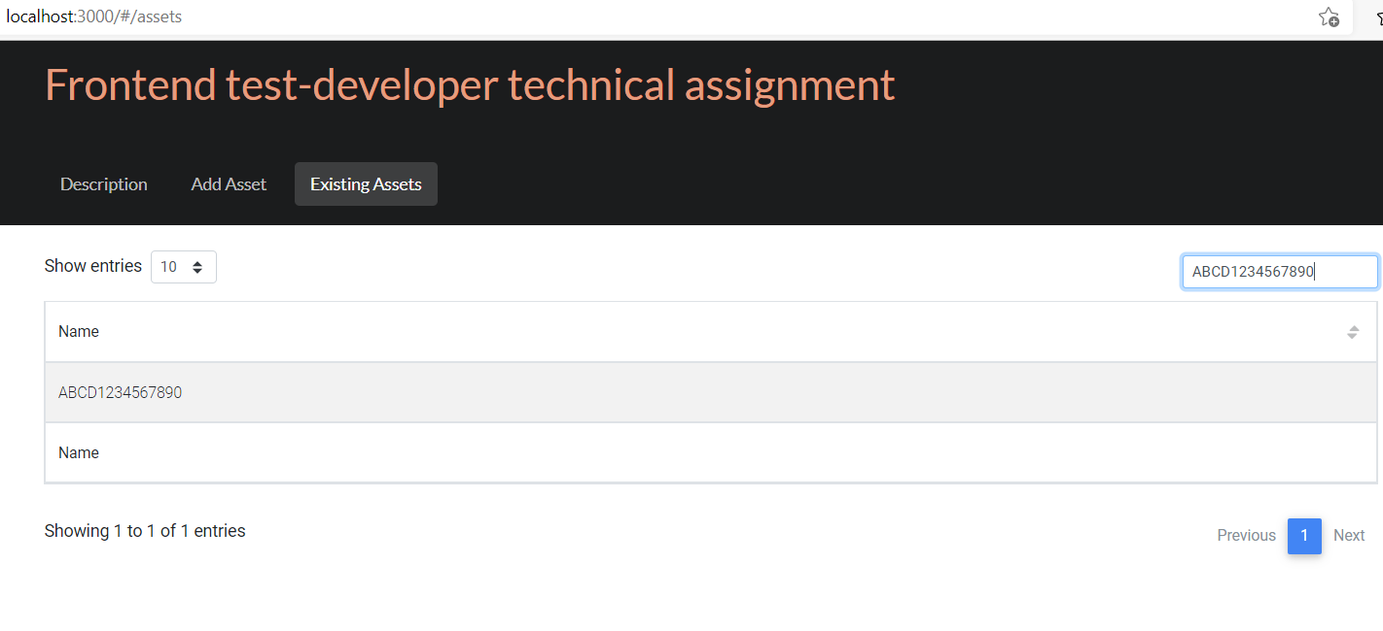

1. Sort Criteria – sorting by ascending and descending

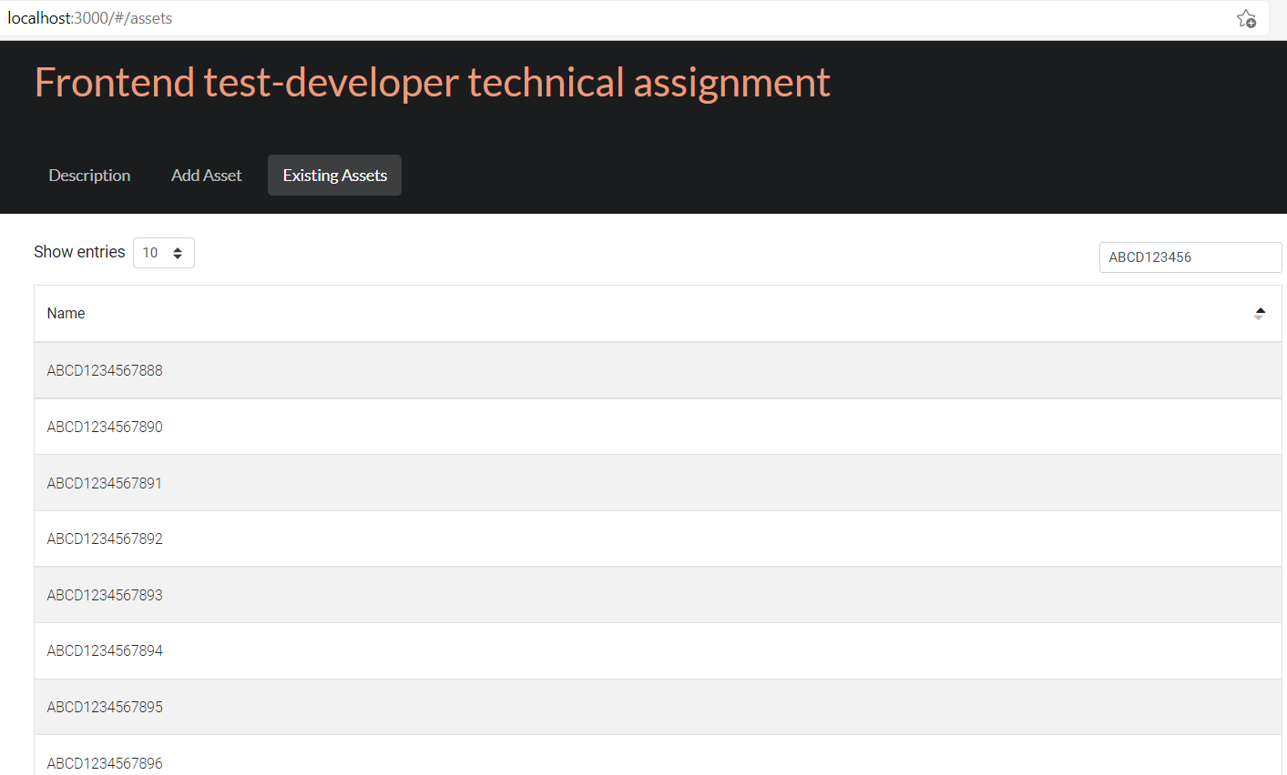

1. Clicking on Next and Previous button

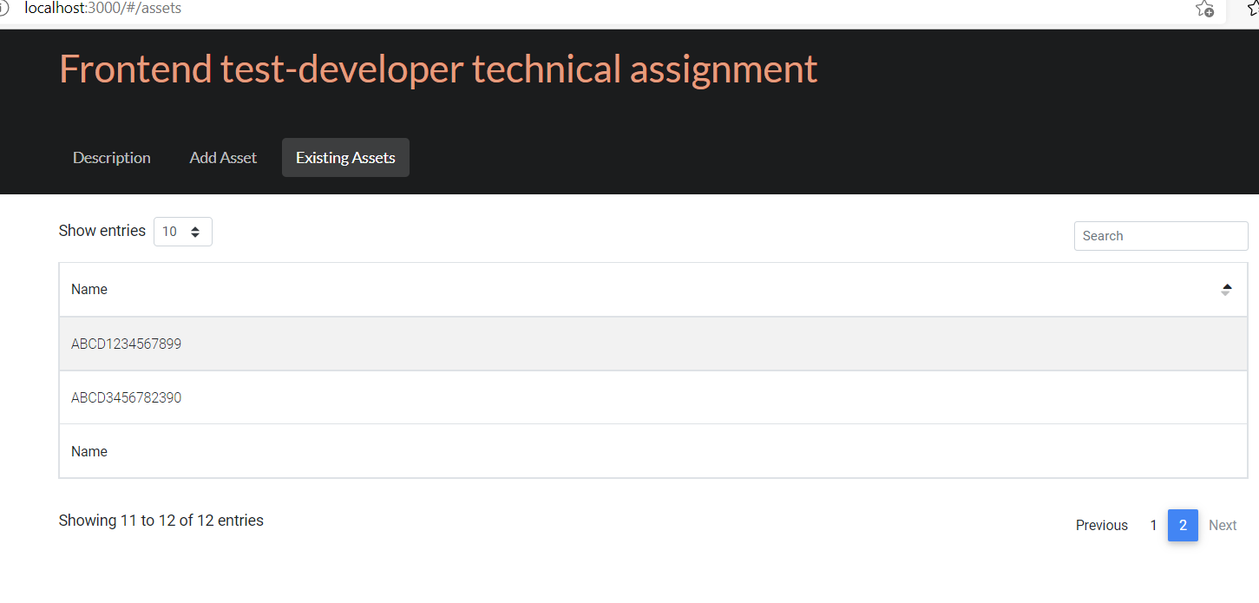

**Negative Scenarios:**

1. While providing invalid Asset format – pop up appears

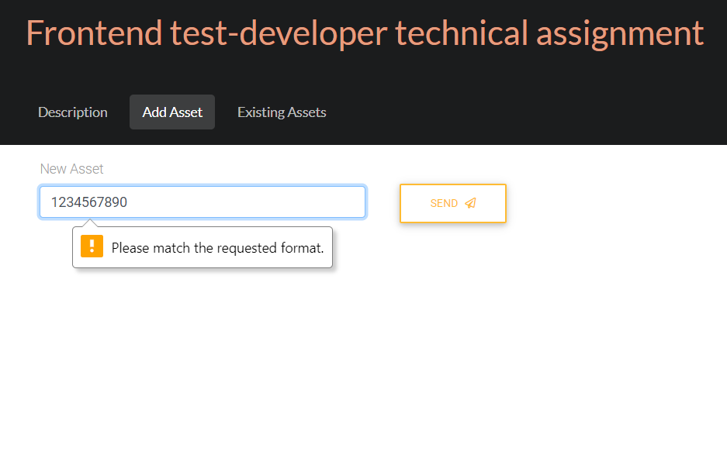

1. Entering invalid Asset format shows in red color and says ‘Incorrect format’

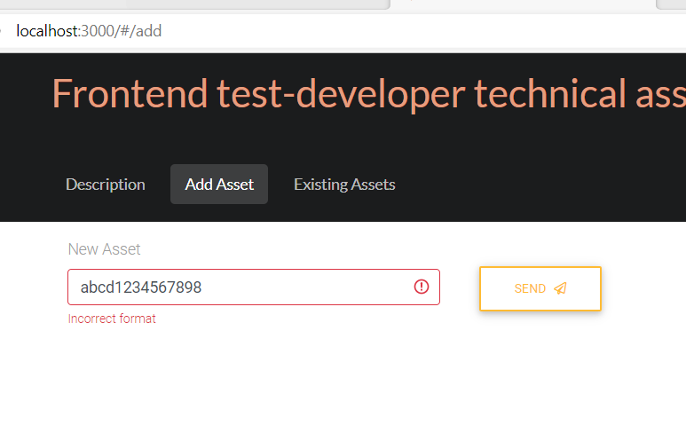

1. Clicking on send without entering any value

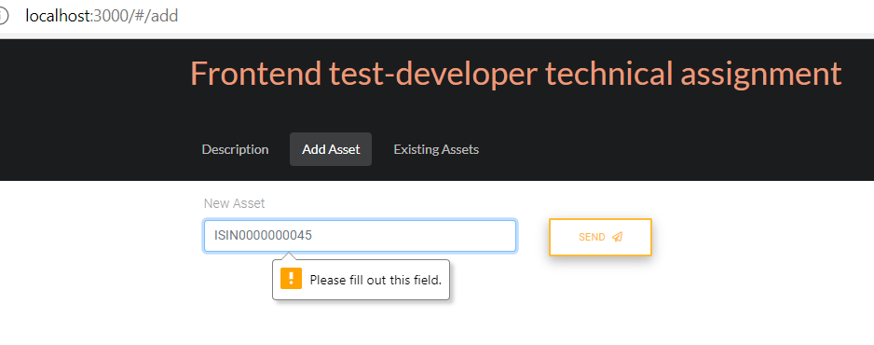

1. In the ‘Existing Assets’ try to search for a new value

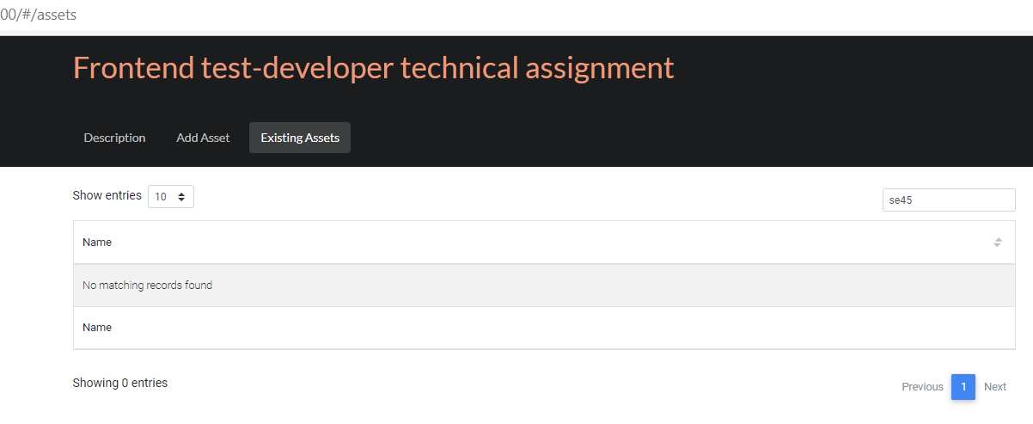

**BUGS**

1. Entries shown with the upward and downward arrow doesn’t work on clicking them instead provides drop down for selection

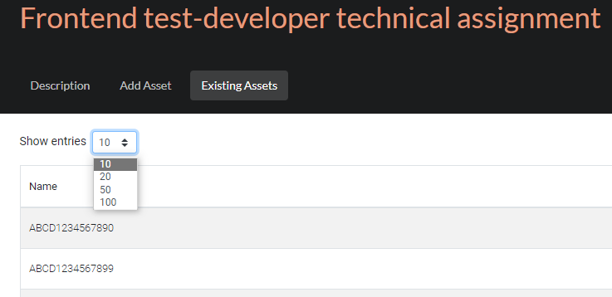

1. ‘SEND’ button is always enabled. It should be enabled only after entering a some values.

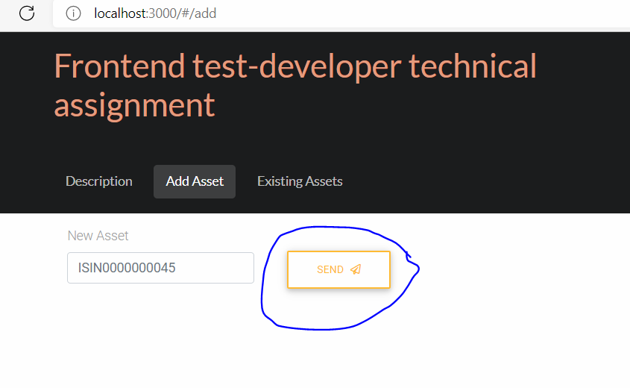

1. When the ‘Existing Assets’ Page doesn’t load, It still shows the loading sign instead of a error page

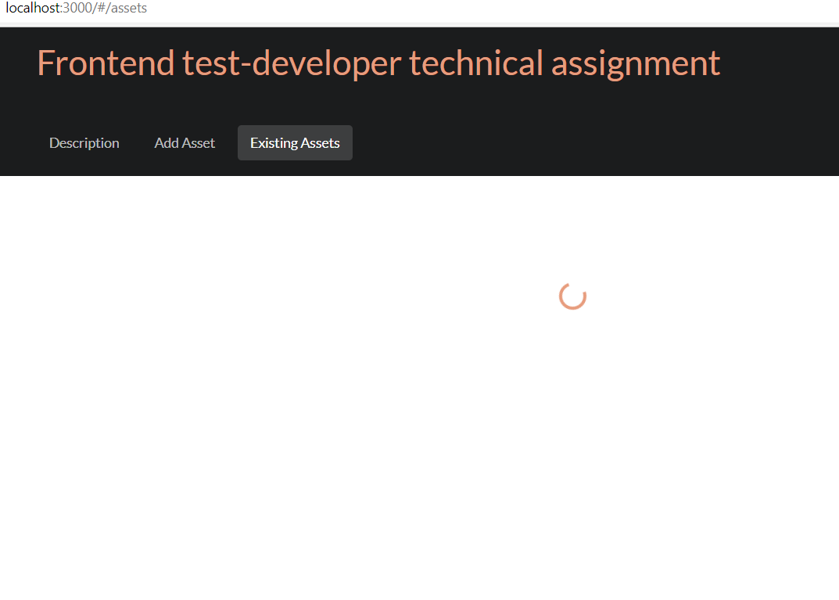

1. Spelling mistake in the description – **digitalis , abbility , assert**

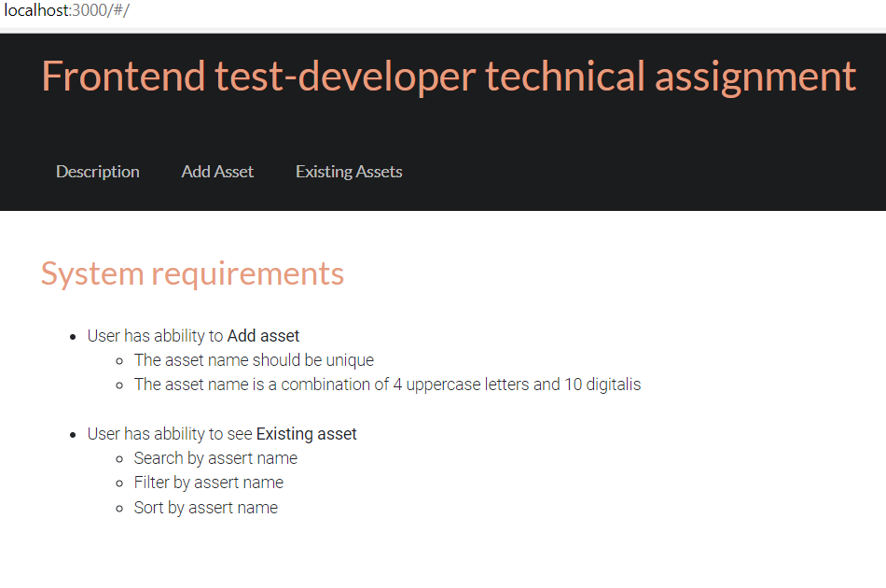

1. Entering an invalid Asset, should prompt an error message

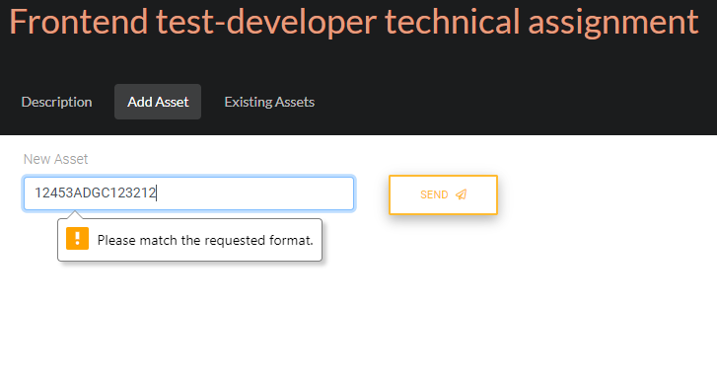

1. ‘Filter criteria’ is not available in the ‘Existing Assets’ 
2. 2 ‘Name’ displayed



1. Spelling Mistakes – **‘alredy’, ‘Assert’**



***********